DFD NOTE (r1/26/02-McKell)

Process Modeling is an important aspect of documenting systems development. Among the various tools and approaches that could be used to model processes, one of the most widely used is the Data Flow Diagram (DFD). The term “Data Flow Diagram” is quite self-explanatory; i.e. it means a diagram showing the flow of data. Typically, a grouping of data will occur as a form, record, or report. Thus, a DFD shows the flow of forms, records and reports. The DFD is called a “process model” because it also identifies the sources of data, the processes that act on that data, the storage repositories where data are stored, and the “sinks” or destinations for the data – i.e. a DFD shows the overall process for manipulating data in some part of an information system. The text book gives an introduction to DFD’s. The purpose of this note is to illustrate how a process narrative can be modeled by a set of data flow diagrams.

It is important to know: a process model typically consists of a set of diagrams showing the process in various levels of detail. The set could be compared to an architect’s drawings for a building. While one drawing is at a very high level showing a rendering of the whole building, another drawing will show the general positioning of truss elements in the roof structure; and still further detail will be shown in how to assemble a single truss; and still further detail may be shown in the exact specification of the steel plate which holds truss beams together at a truss joint. This method of diagramming successive levels of detail is called “exploding.” I.e. one part of a high level diagram is “exploded” to show greater detail on another diagram.

Simlarly, in using DFD’s to model an information system process, we often show a very high level view of the process to allow those involved in the SDLC to see the relationships between the overall system and other entities in the environment. This top level view is called a “Context Diagram.” Commonly, this view is then “exploded” to show the details of what is happening inside of the system. Frequently there are several levels of “explosion,” with each successive level showing details of a subsystem found on its “parent” diagram. Of course these exploded diagrams must be consistent with all other diagrams and documentation at all levels. For example: they should use the same names of entities, data flows, etc. Let’s consider an example. The following describes a process for creating a Personal Financial Plan for a client.

Personal Financial Planning System (PFP System): In preparing a personal financial plan, data is collected from the client on a Personal Data form, and stored in a Client Data file. Data from this file is then used in preparing the client’s Financial Plan report. This preparation process also uses data from an Investment Data file and data from an Economic Data file. Investment Data is obtained by collecting data from various Companies (e.g. from Annual Reports) and Banks (e.g. CDs, etc.). Economic Data is collected from Government Agencies. After a Financial Plan report is prepared, one copy goes to the client, and one copy is stored in a Financial Plan file for future reference.

Using the above example we will first develop a Context Diagram; then we will “explode” that diagram by creating a Level 0 diagram showing details about the process (system) contained on the context diagram. We start by developing the “Context Diagram” to show the overall relationship of this process with its environment – i.e. to show the process in its “context.” In a Context diagram we do not show the internal functions of a system; rather we use a single process symbol to represent the system, and we show the data flows between the system and the external entities in its environment. Also, data stores are not shown in the Context Diagram; they are only shown in the exploded (detail) diagrams.

Step 1: Distinguish the boundaries of the system from the “external entities” with which the system operates. In the PFP system description we observe that there are three external entities: Client, Companies and Banks, and Government Agencies.

Step 2: Identify the data flows that cross the system boundary – i.e. data flows which are exchanged between the system and the external entities. In the PFP system there are four such data flows: Personal Data, Investment Data, Economic Data and the completed Financial Plan. The rest of the description explains processes done internal to the personal financial planning activity. These internal processes are not shown in the Context Diagram, but will be illustrated on a subsequent Level 0 diagram which shows “exploded” detail.

Step 3: Draw the Context Diagram. The result is shown in Figure 1. The diagram depicts the relation of the system with its environment – specifically, the data flows between the external entities and the Personal Financial Planning System. The process is given the name of the over all system. Context diagrams are extremely useful in the early phases of systems analysis to clarify in everyone’s mind what a system is expected to accomplish when it is done. It is a great communication tool between the technicians, the users and management.

Figure 1 – PFP System Context Diagram
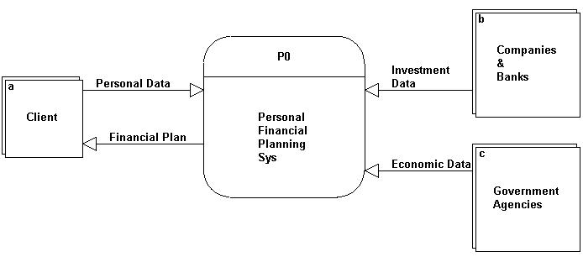

Now, let us examine how this Context Diagram can be exploded to show the next level of detail in the process. (Note: this diagram uses the Gane-Sarson symbol set.)

Step 4: Identify the major sub-processes within the system. In the PFP System we identify 4 sub-processes: Collect Client Data, Collect Investment Data, Collect Economic Data, and Prepare the Client’s Financial Plan.

Step 5: Identify the data stores (i.e. repositories or files). In this case there are four data stores: Client Data, Investment Data, Economic Data, and Financial Plans.

Step 6: Identify the various data flows within the system. The PFP example has four internal data flows: Client Data, Investment Data, Economic Data, and Financial Plan. In this simple case the internal data flows correspond with data stores and external data flows. In more complicated systems there are commonly many more internal data flows and sub-processes.

Step 7: With the parameters identified in Steps 3, 4 and 5, we are now prepared to “explode” the Context Diagram to the next level of detail in a Level 0 diagram. The result is shown in Figure 2.

Figure 2 – PFP System Detail Diagram (Level 0)

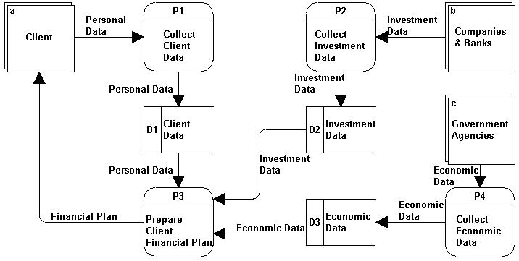

It is instructive to make several observations about these two diagrams and the explosion process. First, these two diagrams constitute a set of related DFDs. Second, there is complete consistency between the diagrams: i.e. the Level 0 diagram contains only entities that appeared on the Context Diagram. Third, all boundary crossing data flows on the Level 0 diagram can be found also on the Context Diagram. This process of insuring consistency between detail levels of the diagrams is called “Leveling the Set.” Also, the explosion process is frequently referred to as “process decomposition.” That is to say, a “parent” process may be “decomposed” into its constituent sub-processes to show another level of detail. As previously explained, this “decomposition” or “explosion” activity may extend through several layers (levels) of detail, so that the DFD description of a system may contain many related diagrams in the set – just like an architect’s set of drawings for a building. Fourth, let’s observe that where the same elements occur on more than one drawing, we passionately adhere to the policy of using exactly the same name for them in all drawings. For example, an entity called “Client” on the Context Diagram is also called “Client” when it appears on the Level 0 diagram. It is very important to strictly adhered to this policy to avoid any confusion when comparing information on one diagram with information contained on another. This is particularly true when using a CASE tool which relies on exact names for linking elements across multiple DFD pages and other SDLC documentation. Finally (fifth), note that the relationships between entities, data flows and processes must be strictly consistent between the various diagrams.
------------------------------------------

Supplemental Example: Below is another DFD example: a typical payroll process.

Figure 3 – Payroll System Context DFD

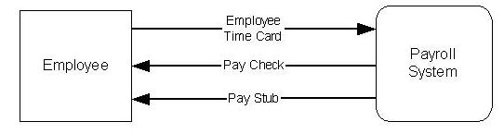

Figure 3 is a Payroll System Context Diagram showing data flows between an Employee and the Payroll System. In the course of daily work an Employee generates a time card that is collected as input to the Payroll System. The system processes the data to create a Pay Check and Pay Stub that are given to the Employee.

Figure 4 – Payroll System Level 0 (Exploded – Detail) DFD

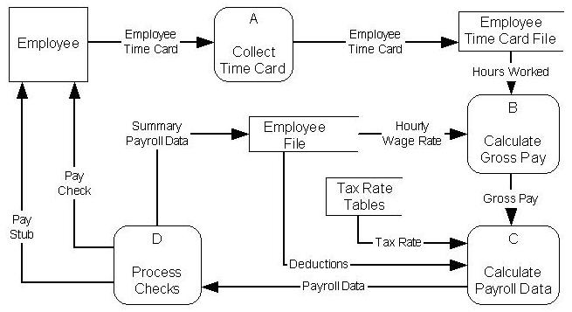

Details of the Payroll System (Level 0 DFD) are shown in Figure 4. Process A collects a time card from the Employee (including the hours worked) and places it in an Employee Time Card File. The Employee Time Card data and the corresponding Employee Hourly Wage Rate (from the Employee Record) are input to Process B for calculating Gross Pay.
This process (Process B) uses the following formula to calculate Gross Pay:

Gross Pay = (Hours Worked) x (Hourly Wage Rate)

The Gross Pay is passed from Process B to Process C which also gets Deduction data from the Employee record file and a Tax Rate from the Tax Rate Tables file as inputs. Process C uses these inputs to calculate the various components of Payroll Data (including the net pay). The Payroll Data is passed to Process D which updates the Employee File with Summary Payroll Data and produces the Pay Check and the associated Pay Stub that are given to the Employee.

Examples of Potential Defects:

To insure that process logic is communicated accurately, DFDs should follow specified rules. When the rules are violated users are left to wonder what is happening in the real system. A basic rule for DFDs is: Every process should have at least one input and one output. Three common mistakes relative to this rule are explained below.

Defect #1: Suppose in Figure 4, the Payroll Data data flow was missing between Process C and Process D. This would leave Process C with no output. Under this circumstance Process C would be called a “black hole” because data goes into the process, but seems to “disappear.”

Defect #2: Similarly, if Process D (Figure 4) were missing the Payroll Data input flow as described in Defect #1 above, it (Process D) would not have what it needs to generate the outputs shown (the Pay Check, Pay Stub, and Summary Payroll Data). Under this defective scenario Process D would be called a “miracle” because it appears to be generating outputs out of nothing (i.e. with no inputs) – obviously a mistake.

Defect #3: Sometimes a process satisfies the basic DFD Rule (above) by having both an input and an output; however, if a needed input data flow is missing, the DFD would be defective. For example, suppose in Figure 4, the “Hourly Wage Rate” data flow is missing from the Employee file into Process B. Although Process B would still have both an input (Hours Worked) and an output (Gross Pay), the input would really not be adequate to compute the desired output (Gross Pay). Under this defective DFD scenario where the inputs to Process B would not be adequate to produce the desired outputs shown, Process B would be called a “gray hole.”

